Guide for MPE suppliers

Contents
1 Scope 3
2 Terms and Definitions 3
3 Target audience 3
4 Technical Requirements 3
5 Registration of a company in SAP Ariba Network procurement system 3
6 Logging in to SAP Ariba Network 10
7 SAP Ariba Network interface management 12
7.1 My account 13
7.2 Company Profile 14
7.3 Users 15
8 Participation in Events 17
8.1 Participation in a Request for proposals 18
8.2 Participation in an Auction 28
9 Useful links 39
10 SAP Ariba Network support 40
10.1 Technical problem 40
10.1.1 Forums 40
10.1.2 Request to SAP Ariba technical support centre 43
10.1.3 Request to NLMK technical support centre 46
10.2 Question concerning business process 46

Scope
This guide describes the following processes: participation in a request for proposals, participation in an auction.

Terms and Definitions
Table 1. List of terms and abbreviations
Term (abbreviation) | Definition
SAP Ariba | A cloud solution designed for managing all procurement processes. The cloud solution comprises several functional modules.
SAP Ariba Sourcing | SAP Ariba module is designed to rate up procurement efficiency and supplier interaction.
Ariba Network (AN) | A business network that allows reciprocation (system document exchange) between the customer and the supplier.

Target audience
This Guide is intended for suppliers. The Guide describes exercising of functions within the scope of supplier’s responsibilities described in “Scope” chapter above.

Technical Requirements
To work with SAP Ariba Sourcing, it is recommended to use Internet browsers of the following versions.
Table 2. Browser versions
Term (abbreviation) | Definition
Internet Explorer | Microsoft Internet Explorer 11 (32-bits OS)
Mozilla FireFox | Mozilla Firefox 48+ (64-bits OS)
Google Chrome | Google Chrome 53+ (64-bits OS)
Microsoft Edge | Microsoft Edge 32-bits
Safari | Safari 9+ (64-bits OS) Mobile Safari browser is not supported by the new SAP Ariba visual design.

Registration of a company in SAP Ariba Network procurement system
NLMK Group procurement system is developed on SAP Ariba platform. When registering in NLMK Group procurement system, your company will be registered in SAP Ariba Network as well. In case you have been invited to the system by NLMK, you will get a letter of notification with a link to the registration to your e-mail.
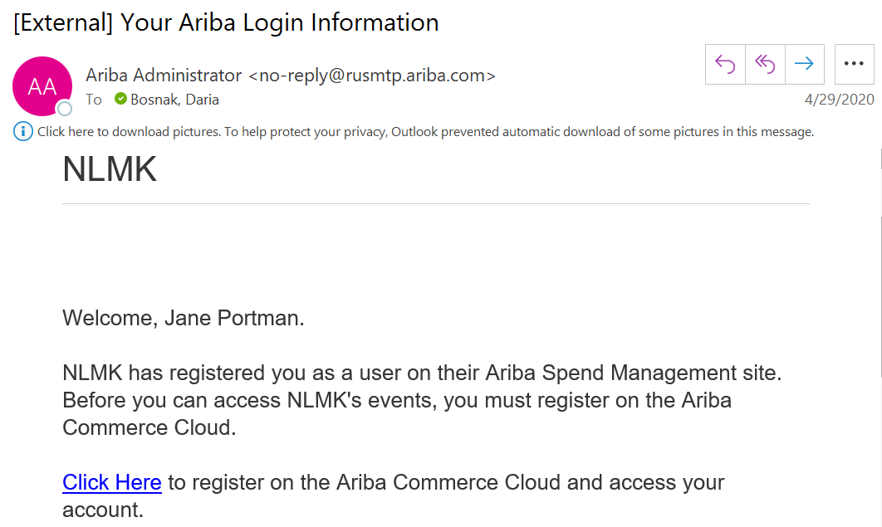
Figure. Sample e-mail notification
After you follow the link, you will see a window where you can do the following:
- register in SAP Ariba Network system (see item 1), if you don’t have an account,
- or log in, if you have already had an account (see item 2):

- If you don’t have an account, click “Sign up’ link to start the procedure of registration in the system.
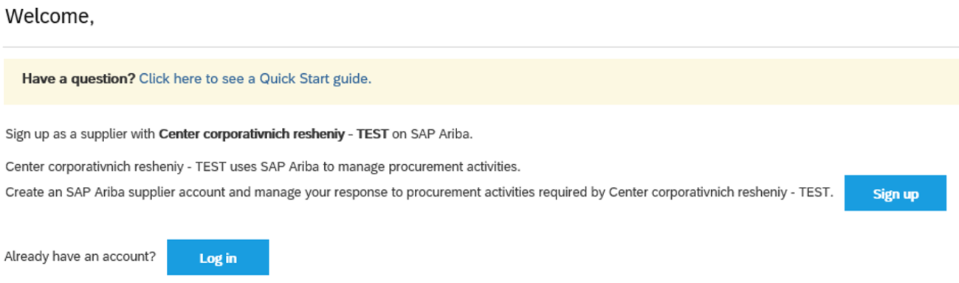
Figure. Registration selection
- If you have an account, click “Log in” (see “Logging in to SAP Ariba Network” chapter) to access the system.
Figure. Registration selection
In the next popup window fill in the fields in “Company Information”, “User account information»” and “Tell us more about your company” sections.
In “Company Information” section you shall specify the following information about your company:
Table 3. Description of fields
Field | Description
Company name | Specify your company name.
Company name (in Latin letters) | Specify the name of your company in Latin letters.
Country | Select your country name in the drop-down list.
Postal code | Specify your company’s postal address.
Postal code (in Latin letters) | Specify your company’s postal address in Latin letters.
State/region | Select your state or your region in the drop-down list.
City | Specify a city where your company is located.
City (in Latin letters) | Specify a city where your company is located in Latin letters.
Address | Specify your company’s address (legal). Specify information on the company’s street, house and office number.
Address (in Latin letters) | Specify your company’s address (legal) in Latin letters. Specify information on the company’s street, house and office number.

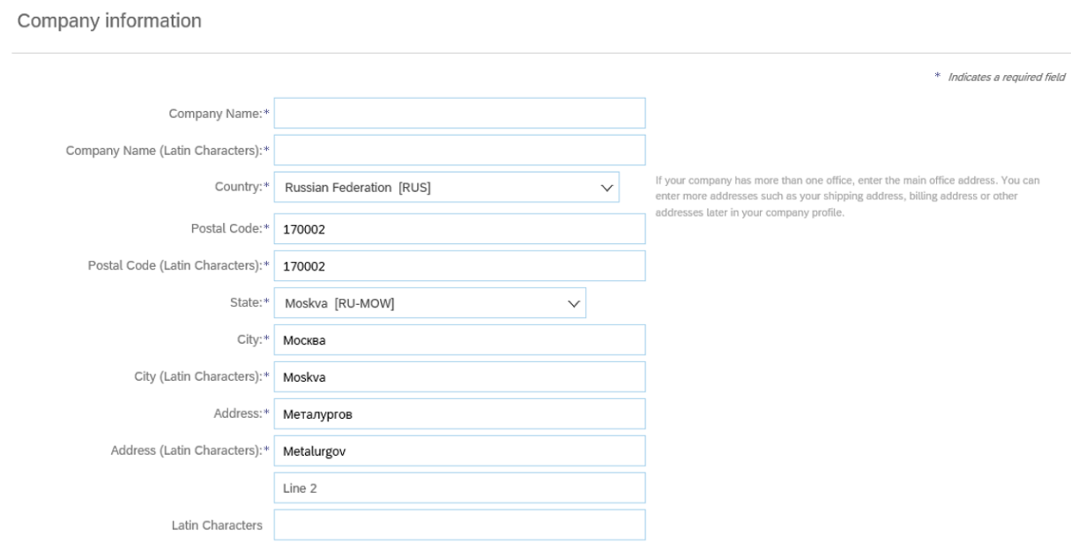
Figure. “Company Information” section
In “User account information” section enter information on a person in charge from your company’s side:
Table 4. Description of fields
Field | Description
Name | Specify the name and the surname of a person in charge in the respective fields.
E-mail | E-mail address where a proposal for registration was sent is set as default.
Username | Specify user name - your login which you will use when entering the system. The user name shall be in the following format: “alina.novak@accenture.com”.
Password (two lines) | Create a password which shall have at least 8 characters including letters and figures, and enter it in the first line.
 | Repeat the password in the second line.
Language | Select a language which will be used in Ariba notifications.
E-mail orders to | Specify e-mail address where you will receive offers from customers.

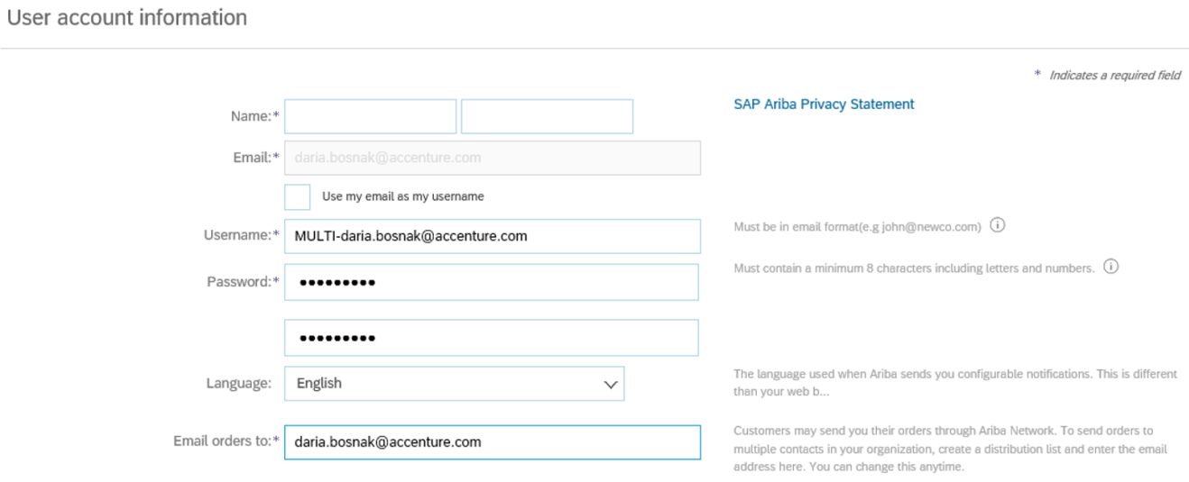
Figure. “User account information” section
In “Tell us more about your company” section enter additional information about your company.
When registering, you shall indicate categories of goods and services supplied. Universal Standard Products and Services Classification of the United Nations (UNSPSC) is used in the system. You can select categories of goods and services by the following means:
- To select a category of goods and services, you can start entering the name in the line, and after that a list of possible categories will appear. Select a suitable option in the dropdown list. If you need to add more, click “Add” button. If you want to delete the selected category, you need to click “X” next to the name of the respective category.
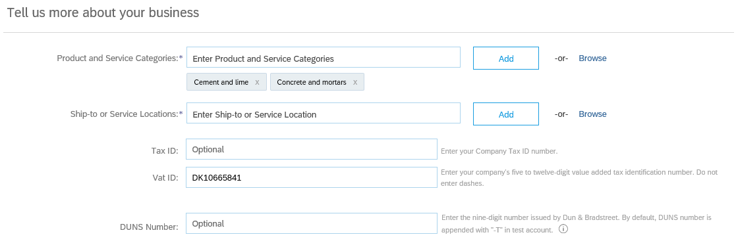
Figure. “Tell us more about your company” section
- To select a category of goods and services, click “Browse”.
Figure. «Tell us more about your company» section.
You will see a window for adding categories of goods and services. When clicking respective categories of goods and services, you will see a more detailed list for the selected category. To add suitable categories into your profile, you need to click “+”. You can select more common categories, as well as more detailed ones at the same time. You can select several categories simultaneously. The selected categories will appear at the bottom in “My selections” line. Upon completion click “OK”.

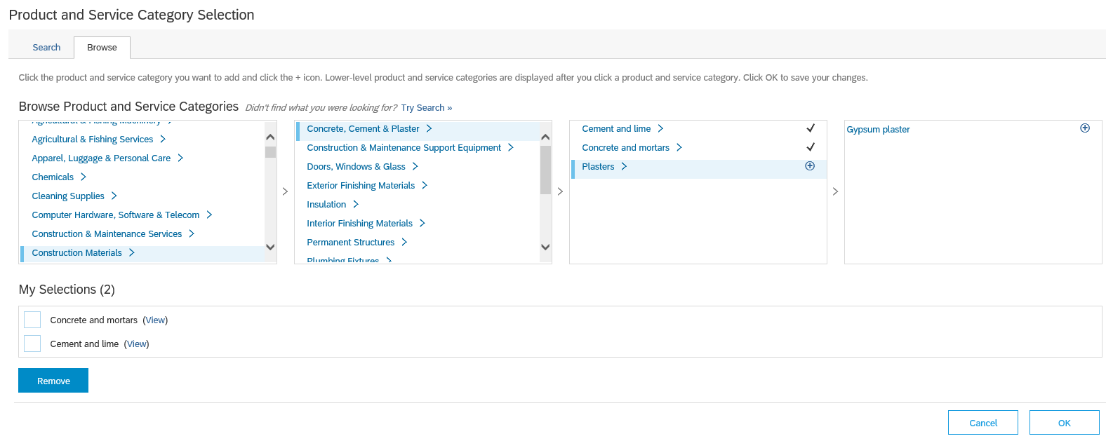
Figure. Selection of categories of goods and services
When registering, you need to indicate regions of services rendering. You can do it by several means:
- To select a region (regions), you can start entering the name in the line, and after that a list of possible regions will appear. Select a suitable option in the dropdown list. If you need to add more, click “Add” button. If you want to delete the selected region, you need to click “X” next to the name of the respective region.
Figure. “Tell us more about your company” section
- To select a region (regions), click “Browse”.
Figure. “Tell us more about your company” section
You will see a window for adding regions. When clicking the respective locations, you will see a more detailed list. To add suitable regions into your profile, you need to click “+”. You can select more common categories, as well as more detailed ones at the same time. You can select several regions simultaneously. The selected regions will appear at the bottom in “My selections” line. Upon completion click “OK”.
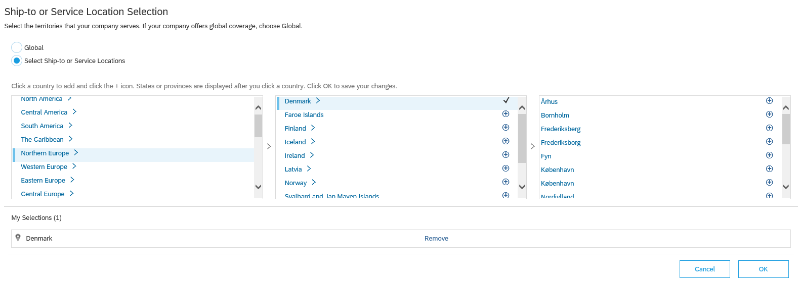
Figure. Selection of regions
Specify Tax ID, Vat ID, DUNS Number.
Figure. “Tell us more about your company” section
Note. Data specified during the registration can be adjusted later on.
Next, study “Terms of use” and “SAP Ariba Privacy Statement” (by clicking the names) and mark the items with a tick in order to continue. Then, click “Create account and continue” button.
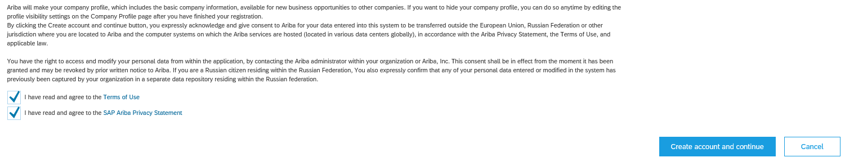
Figure. Documents review
Upon completion of the registration, you will get a welcome letter from SAP Ariba by e-mail.
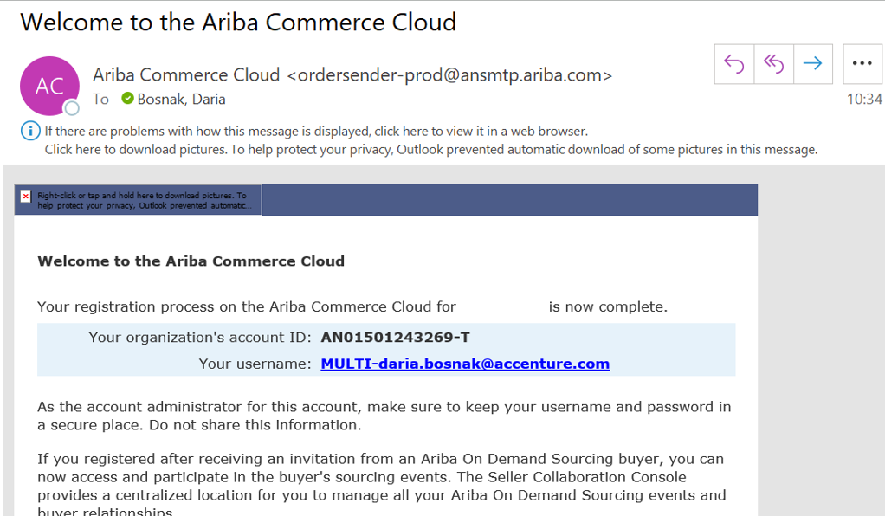
Figure. Sample e-mail notification

Logging in to SAP Ariba Network
- To access the system, you need to follow.
- The appeared window will request you to enter data for logging in to the system. Enter your “Username” and “Password” and click “Login”.
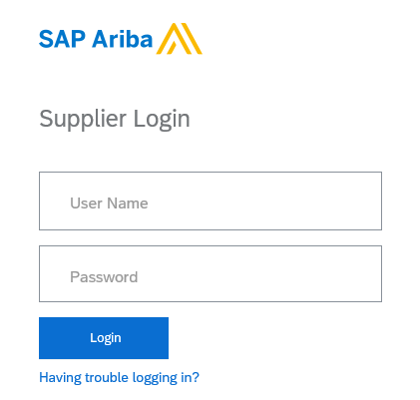
Figure. SAP Ariba Network login page
- If you face problems with logging in to the system, use link “Having trouble logging in?”
Figure. SAP Ariba Network login page
In the popup window enter your e-mail address registered in Ariba account. You will receive a message with additional instructions after these data confirmation.
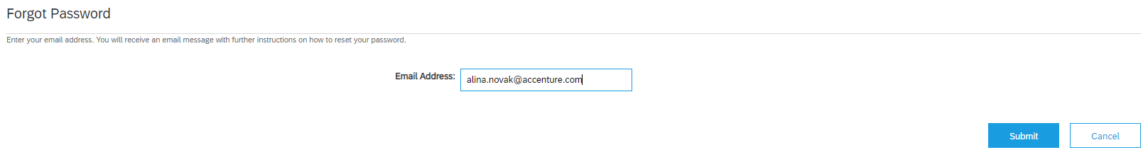
Figure. Restore username and password
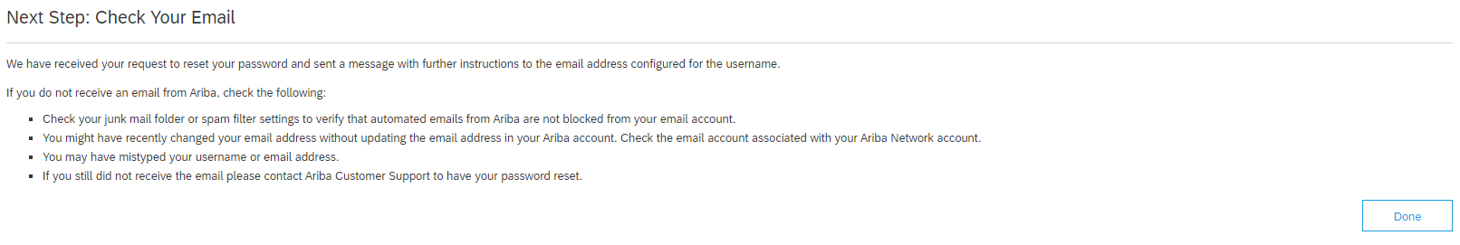
Figure. Restore username and password

SAP Ariba Network interface management
Upon authorization in the system, you will see your personal account.
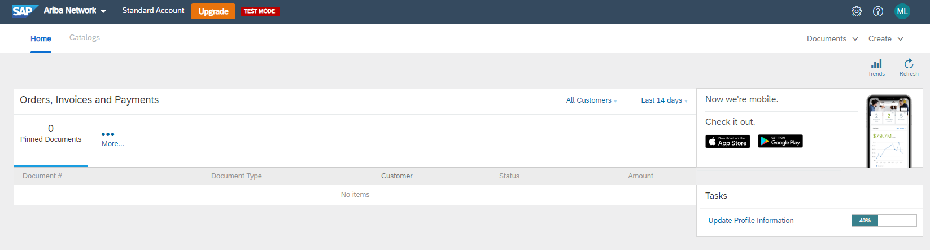
Figure. Home page
Next, you shall go to “Ariba proposals and questionnaires” section for further work. For this purpose, click “Ariba Network” in the top left corner of the screen and select “Ariba proposals and questionnaires” option in the drop-down list.
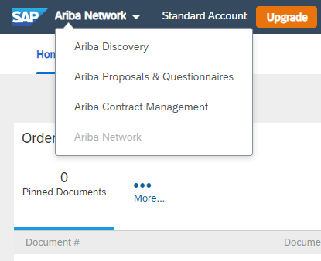
Figure. “Ariba Network” button drop-down list
Here you can view Events which you have been invited to participate in.
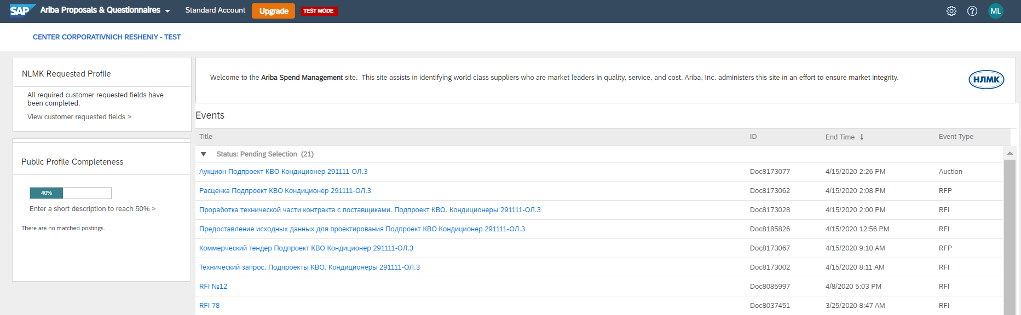
Figure. Home page
Events listed on the home page are broken down into 3 categories: open, pending selection, closed. You can go to the event by clicking its name.

My account
In order to change user information, click the profile icon in the top right corner of the page and select “My account” option in the drop-down list.
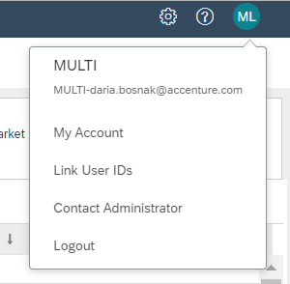
Figure. Drop-down list
Here you can adjust user data: add required data and change the existing ones. Upon introduction of modifications, click “Save”.
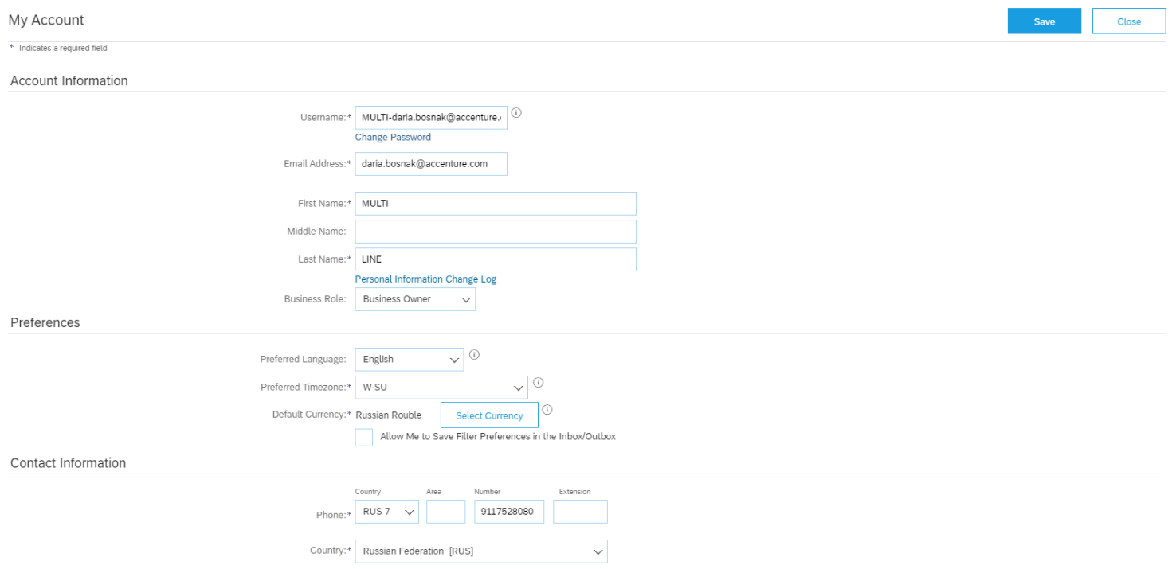
Figure. Account data modification mode

Company Profile
In order to change information about your company, click a gear icon in the top right corner of the page and select “Company profile” option in the drop-down list.
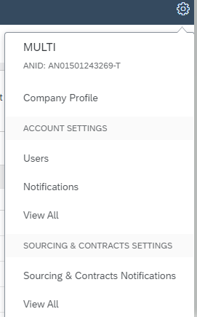
Figure. Drop-down list
Here you can adjust your company data: add required data and change the existing ones. Upon introduction of modifications, click “Save”.
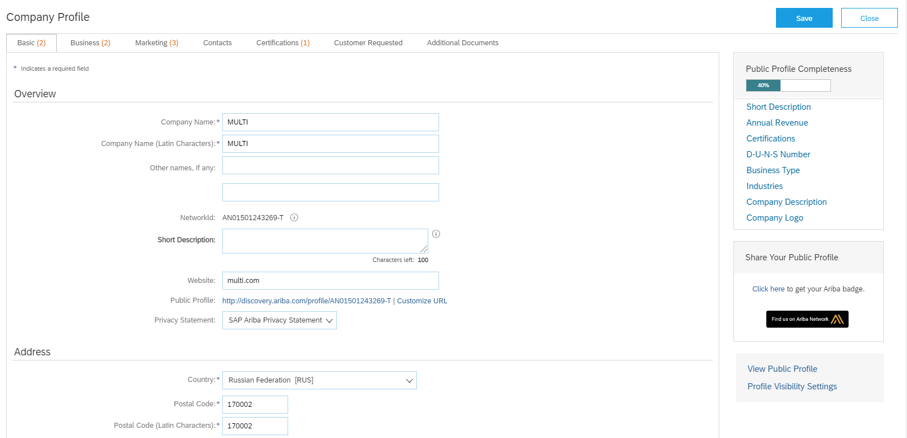
Figure. Account data modification mode

Users
In order to manage the users, click a gear icon in the top right corner of the page and select “Users” option in the drop-down list.
Figure. Drop-down list
You may add more users who can log in to the account and view events (authorized persons from your company).
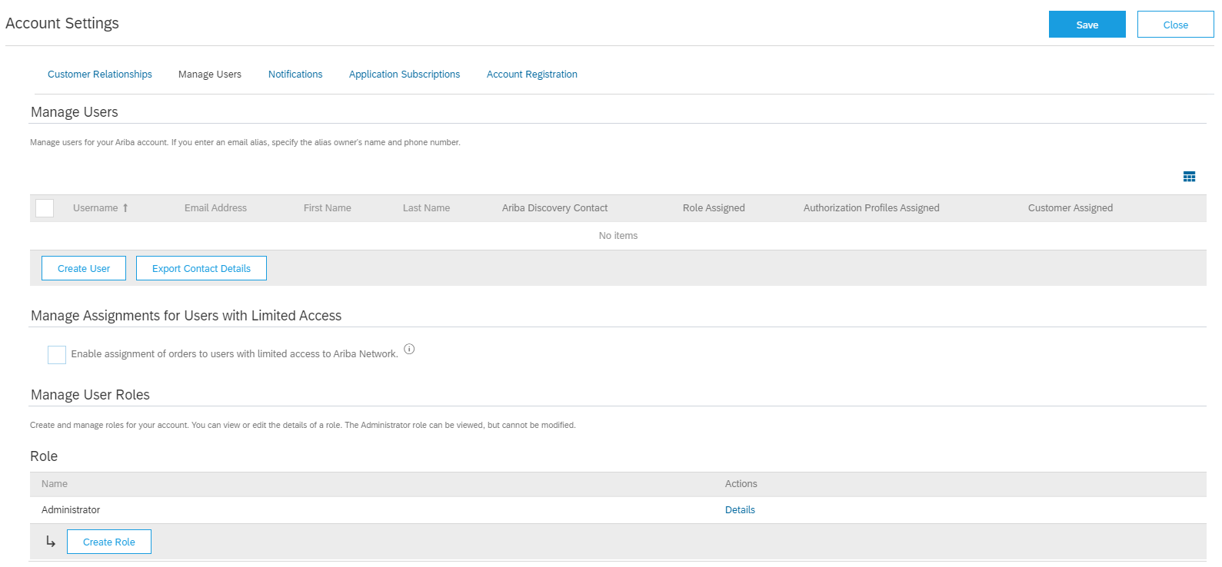
Figure. Users management
In order to create a user, click “Create a user”.
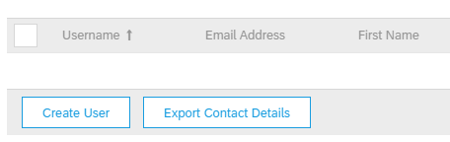
Figure. Users management
In the popup window enter information about a new user: username, e-mail address, name and surname and phone number.
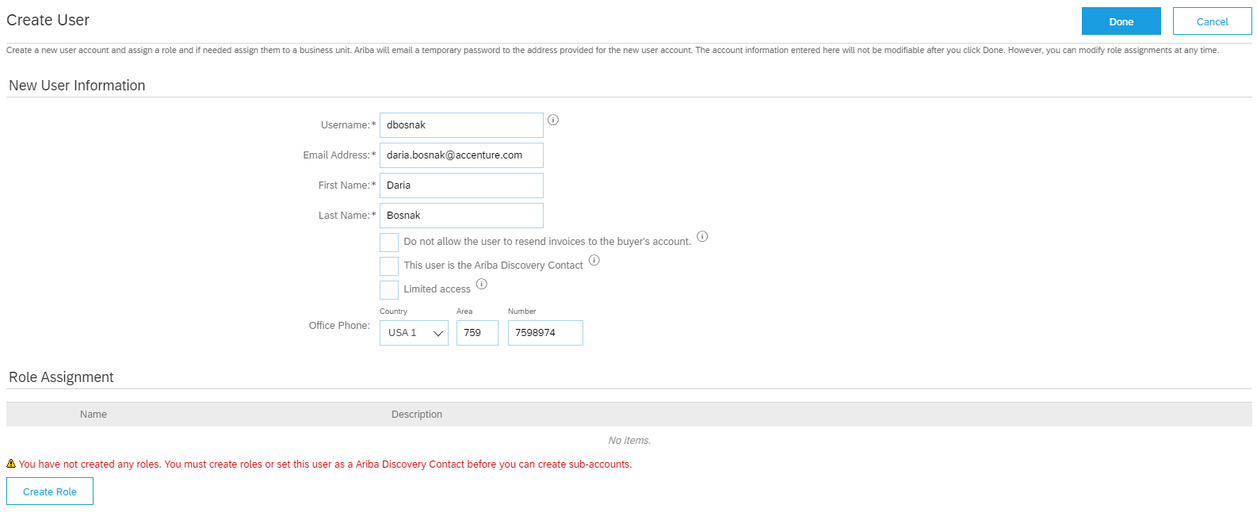
Figure. Create a user
Next, create a role for him which he will carry out by clicking “Create a role”.
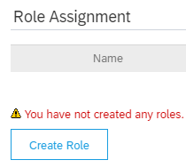
Figure. Create a role
In the popup window give a name to the role which an invited person will fulfil. In “Permissions” section select “Access proposals and contracts”. Upon completion click “Save”.
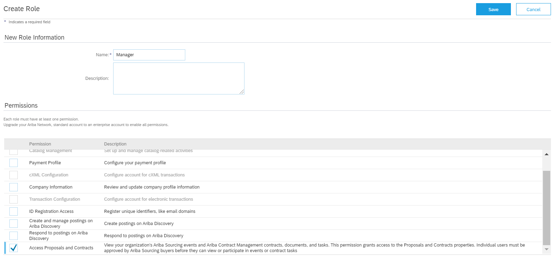
Figure. Create a role
Upon introduction of modifications mark a suitable role with a tick and click “Done”.
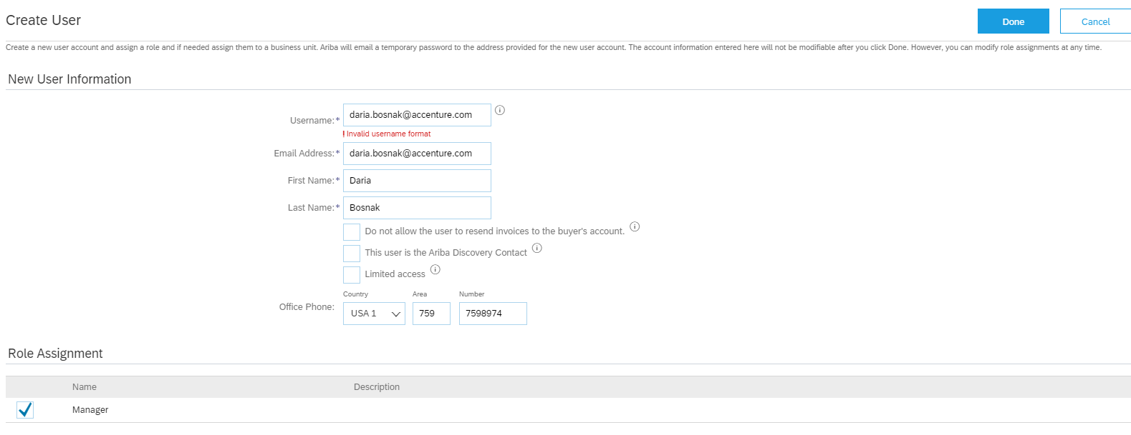
Figure. Create a user

Participation in Events

Participation in a Request for proposals
After NLMK invites you to participate in a Request for proposals, you will receive a letter of notification by-email. Follow the link and log in to the system (see “Logging in to SAP Ariba Network” section).
Note. You can go to the Event via SAP Ariba Network interface.
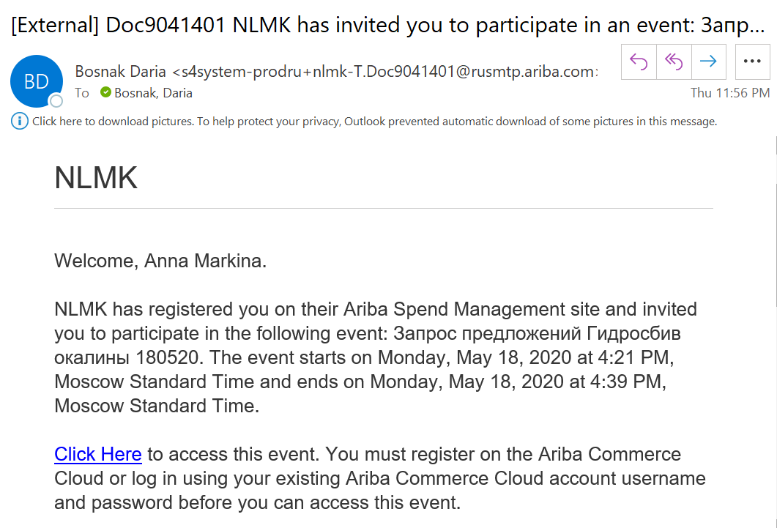
Figure. Sample e-mail notification
After authorization you will see a page of Request for Proposals Event. Next, you need to study the terms of participation. For this purpose, you need to click “Review Prerequisites”. (You need to accept the terms of participation before you can view the event content or take part in it).
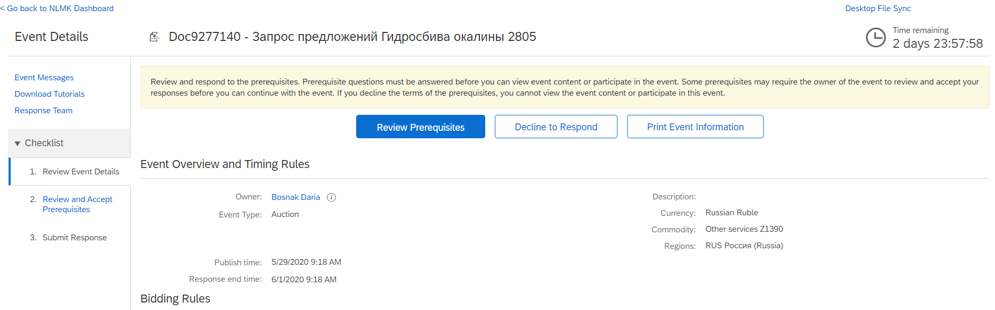
Figure. Event page
Note. In the top right corner you can see the time of the Event (how much time is left before the end of the Event).
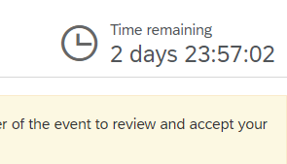
Figure. Time of the Event
Study the terms of participation in a Request for proposals and mark a suitable option with a dot (whether you agree with the terms or not). Then click “Ok”.
Note. If you reject the terms, you will not be able to view the event content or take part in this event.
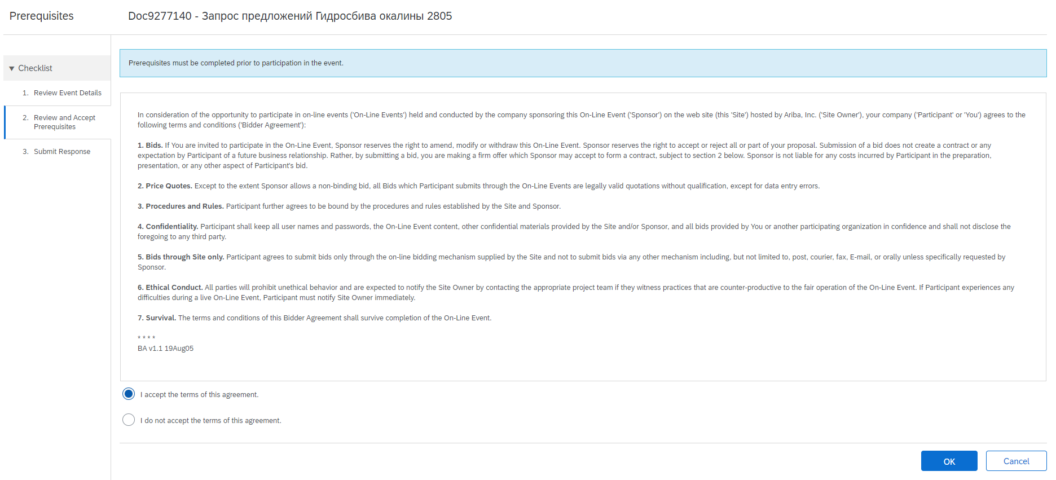
Figure. Review of the terms of participation
In the popup window click “OK” to continue.
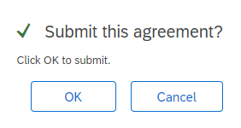
Figure. Response affirmation
Then in “Submit Response” tab you shall study the documents and answer the questions in “General provisions” section.
If you want, you can download Instructions for Supplier. For this purpose, click on «Instructions for Supplier», select a suitable document in the drop-down list. It will start downloading to your computer where you can study it.
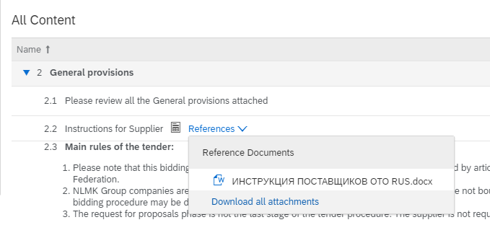
Figure. Instructions for Supplier
Next, study “Main rules of the tender”. It is important information about this Event.
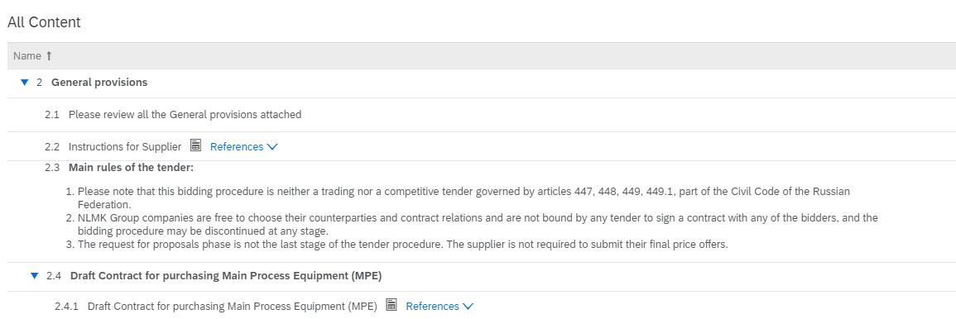
Figure. Main rules of the tender
Next click the name of “Draft Contract for purchasing Main Process Equipment (MPE)” question, and you will see a document with a Draft Contract in Russian and a document with a Draft Contract in English in the drop-down list. Select a suitable option. It will start downloading to your computer where you can study it.
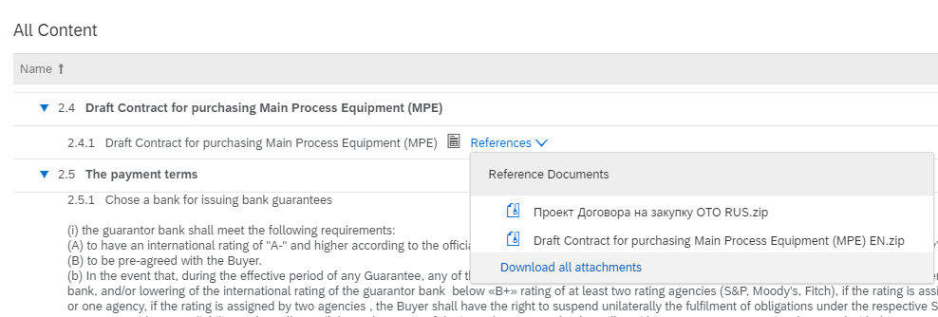
Figure. “Submit Response” tab
Next, select a bank for issuing bank guarantees in the respective field. You can select a suitable option in the drop-down list.
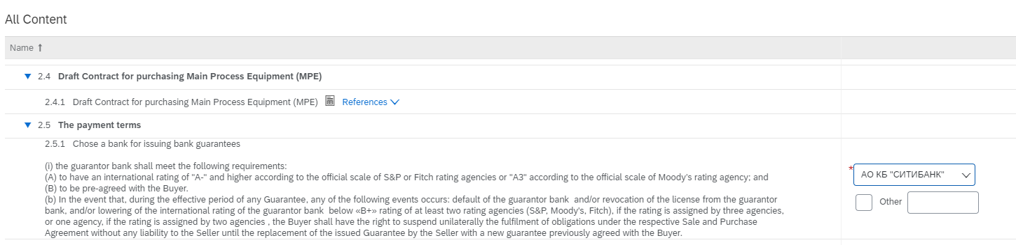
Figure. “Select a bank for issuing bank guarantees” drop-down list
If there is no suitable option in the list - enter your own one. For this purpose, put a tick next to “Other” and enter the name of the bank in the field next to it.
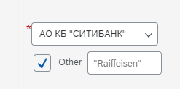
Figure. Enter the name of a bank for issuing bank guarantees
Next, click the name of the following question: “Consent to the penalties / LDs in the amount established in Appendix B resulting from the breach of environmental and OHS regulations applicable on the Buyer's site caused by the Seller, the Contractor, and/or their employees and representatives”, and you will see a document with Appendix B in Russian and a document with Appendix B in English in the drop-down list. Select a suitable option. It will start downloading to your computer where you can study it.
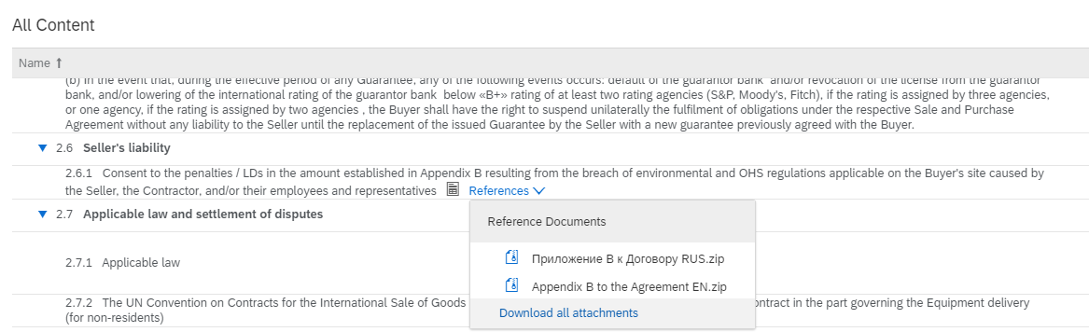
Figure. “Submit Response” tab
Next, in “Applicable Law” field select an applicable law in the drop-down list.
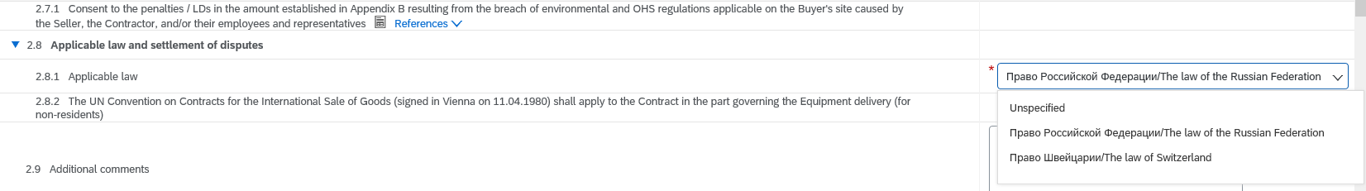
Figure. “Submit Response” tab
The question “The UN Convention on Contracts for the International Sale of Goods (signed in Vienna on 11.04.1980) shall apply to the Contract in the part governing the Equipment delivery (for non-residents)” informs that this convention will apply to the Contract part governing the equipment delivery.
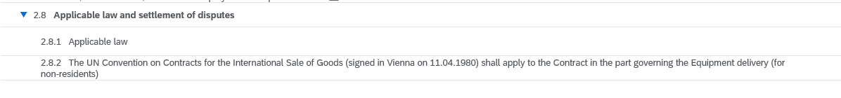
Figure. “Submit Response” tab
If you need you can add comments in “Additional comments” field.
Figure. “Submit Response” tab
Upon completion, go to the beginning of the list of “All content” section and opposite “Please review all the General provisions attached” question put “Agreed” value in the drop-down list after studying the documents in “General provisions” section.
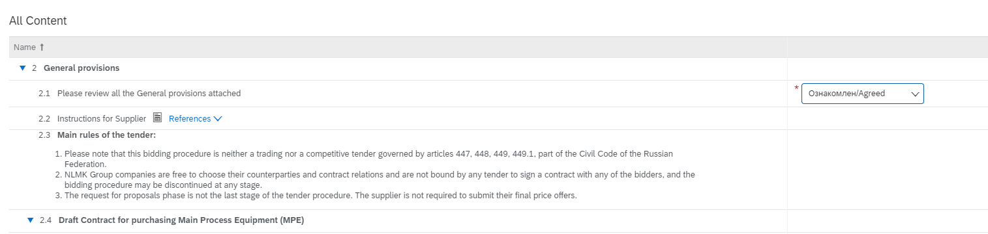
Figure. “Submit Response” tab
Further on data will be entered in Excel format. In the same “Submit Response” tab at the bottom click “Excel Import”.
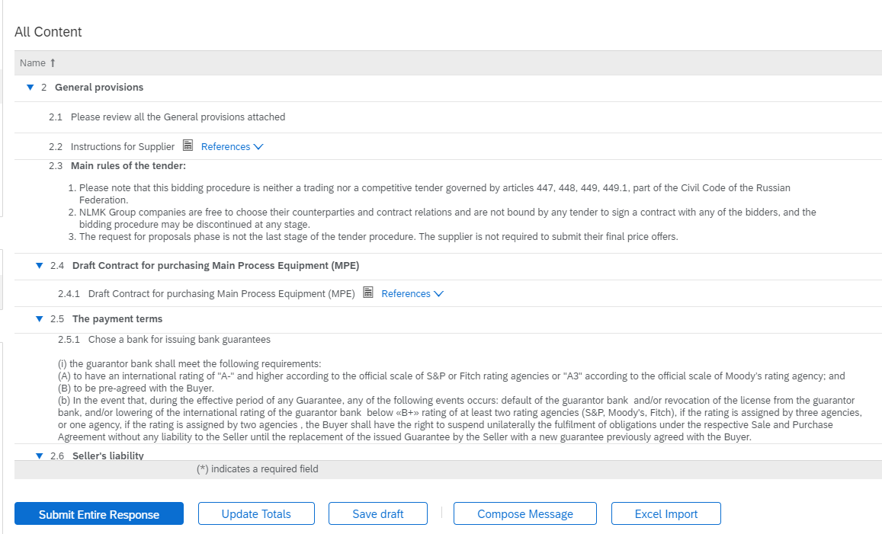
Figure. “Submit Response” tab
Next, click “Download Content”, and after that an Excel-document will start downloading to your computer where you will continue to work further on.
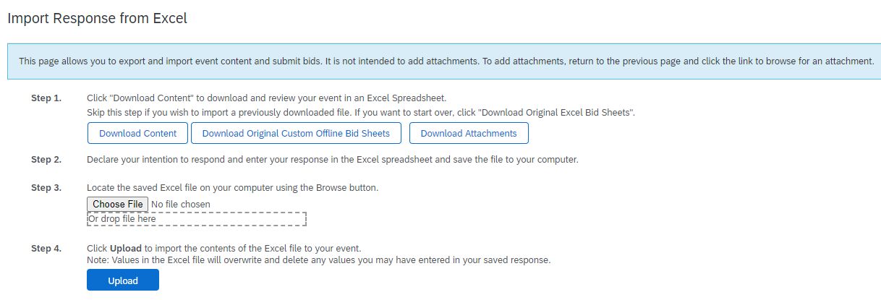
Figure. Downloading a document to the computer
Open a file which you have just downloaded. Study the content on “Предложения.Proposals” sheet. Here you will see the main sections: Contract terms, Contract price, Payment terms, Delivery time and the Seller’s responsibility.
Important! All the questions in “Contract price” section are specified for one set of the equipment.
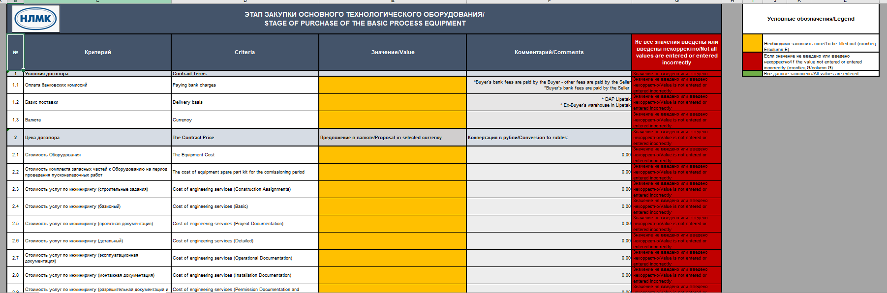
Figure. Excel
You shall enter data in the cells highlighted in orange in “Значение/Value” column (reference to this you will see in the top right corner of the sheet).
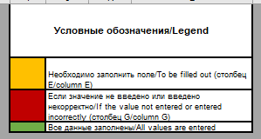
Figure. Legend
The cells highlighted in red shall not be filled in as they are filled in automatically as soon as the requirement specified in the cell is met.
Important! After you fill in all the data correctly, red cells will disappear. Make sure that there none of them left!
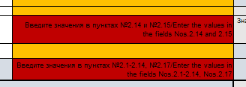
Figure. Red cells
In “Комментарии/Comments” column you can see auxiliary comments which can show you the translation of the respective cells in “Значение/Value” column or describe the limitations of these cells.
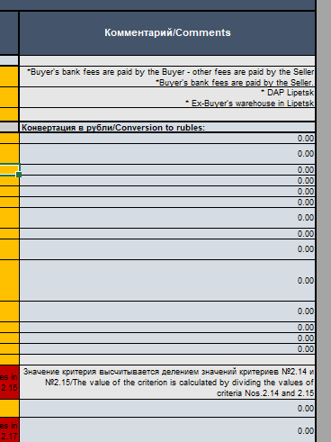
Figure. “Комментарии/Comments” column
Besides, in this column you will see a currency converter to Russian rubles. It automatically converts the data from the respective cells in “Значение/Value” column if you have selected other currency in “Currency” field.
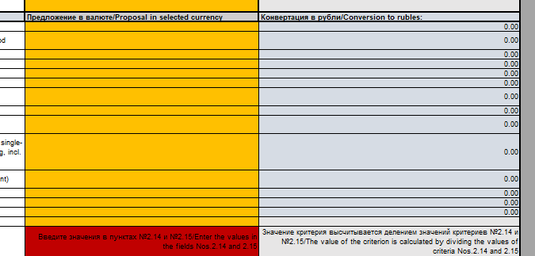
Figure. Currency converter
After you finish entering all the data in the Excel-document, you shall upload this file to Sap Ariba system. For this purpose, click “Choose File” button in SAP Ariba system and upload a required file.
Figure. Document uploading to the system
After that click “Upload”.
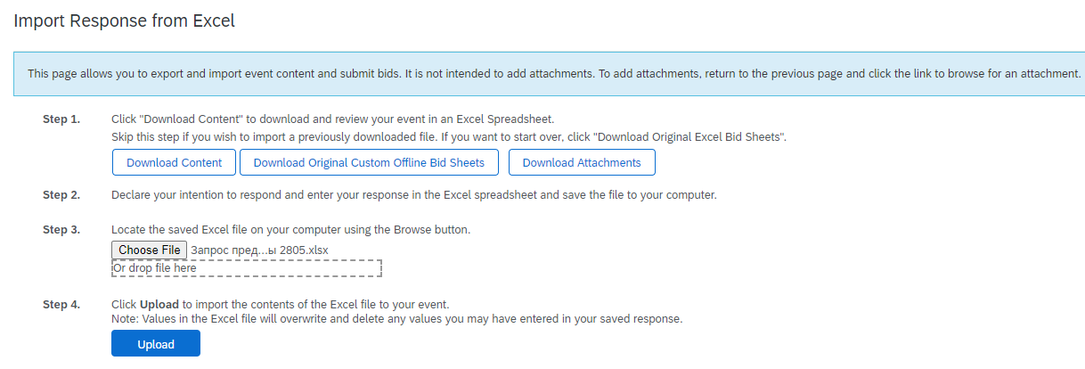
Figure. Document uploading to the system
If you see Error like in screenshot below that means not all values are provided or provided incorrectly in Excel. Please check red cells in Excel.
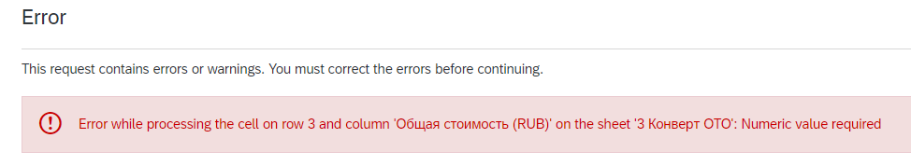
Otherwise, in the popup window you will see a message saying that the import has been done successfully. Click “OK”.
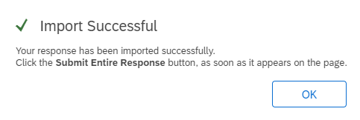
Figure. Finish the import
Next, click “Submit Entire Response” in order to send your proposal.
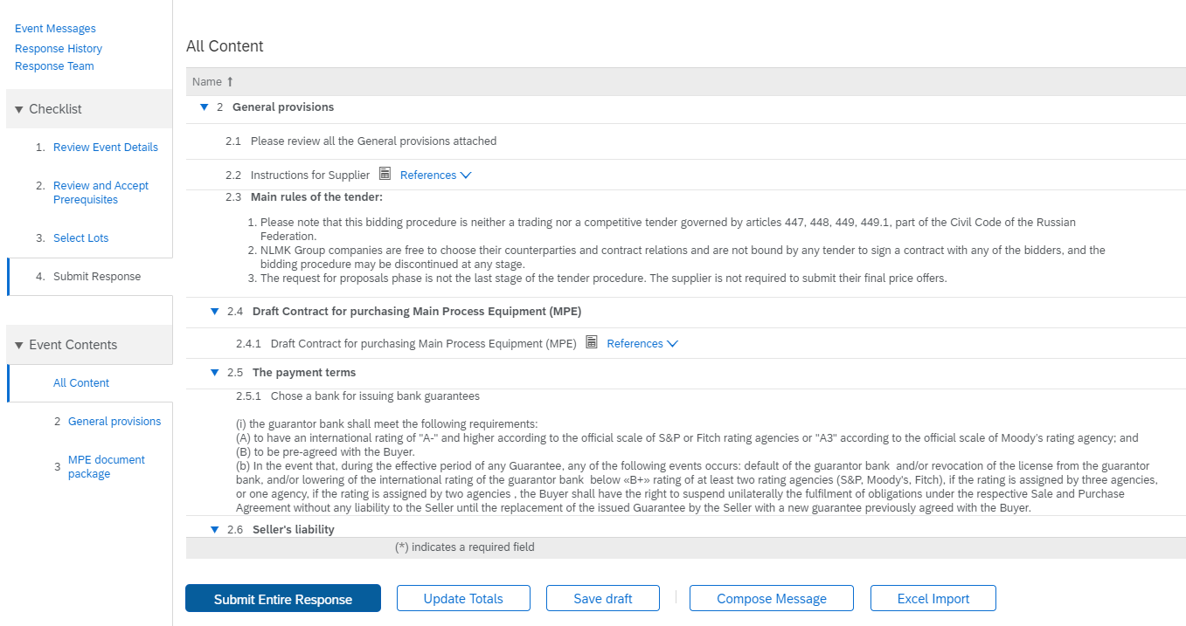
Figure. “Submit Response” tab
In the popup window click “OK” to continue.
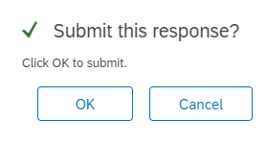
Figure. Response affirmation
If necessary, you can edit your responses before the end of the Event. For this purpose, click “Revise Response”.
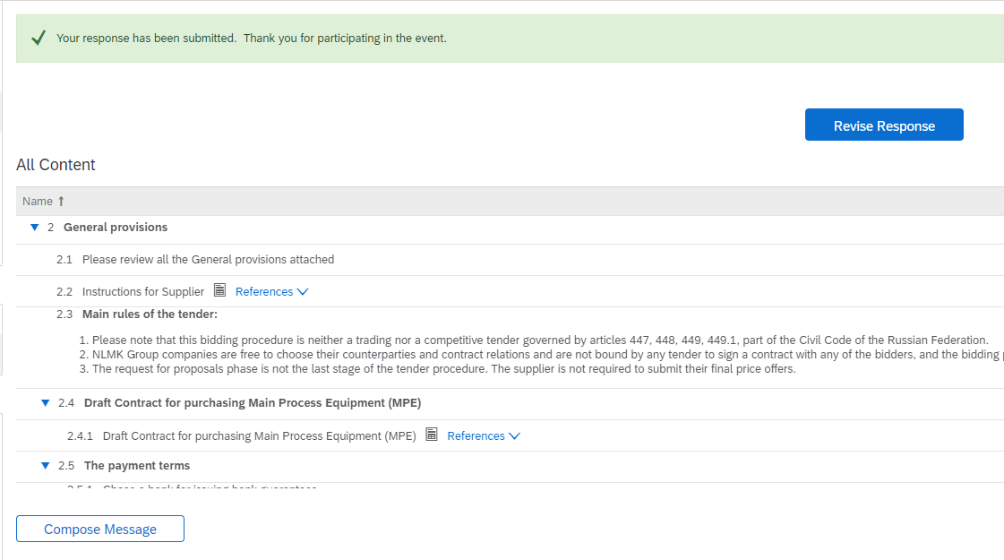
Figure. Response revising
In the popup window click “OK” to continue.
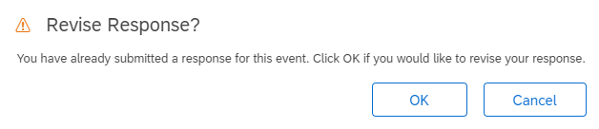
Figure. Response affirmation
After the event is finished, you will get a letter of notification by e-mail.
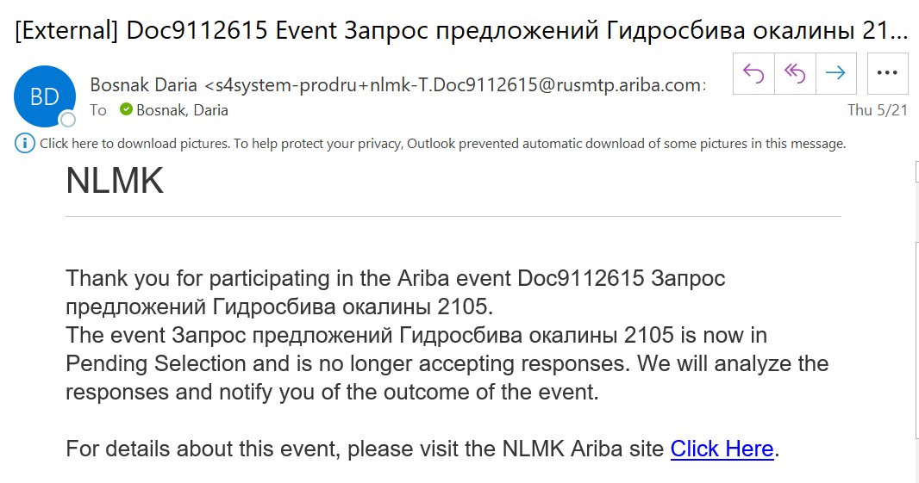
Figure. Sample e-mail notification

Participation in an Auction
Participation in an Auction implies several stages of its conducting. The number of the stage and quantity of stages will be reflected in the name of Events. Thus, you can see the stages that haven’t started yet in “Preliminary consideration” folder in the system interface.
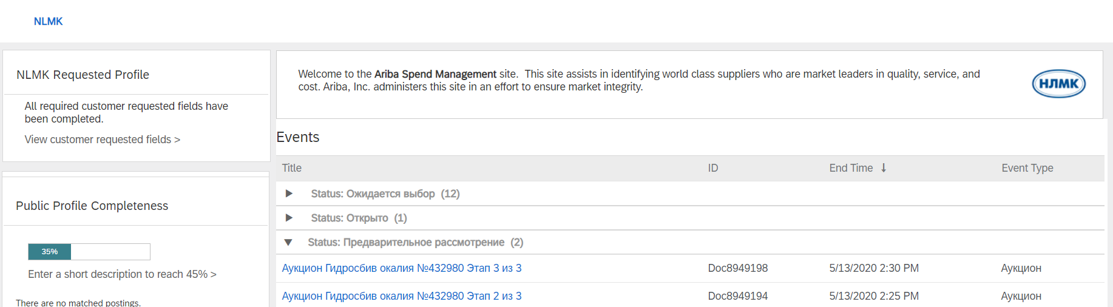
Figure. SAP Ariba Network home page
After NLMK invites you to participate in an Auction stage, you will receive a letter of notification by-email (a letter will come after invitation to each stage). Click the link and log in to the system (see “Logging in to SAP Ariba Network” section).
Note. At each further stage of an Auction you shall improve your proposals and go through the whole cycle described in this section - No.8.2 “Participation in an Auction”.
Note. You can go to the Event via SAP Ariba Network interface.
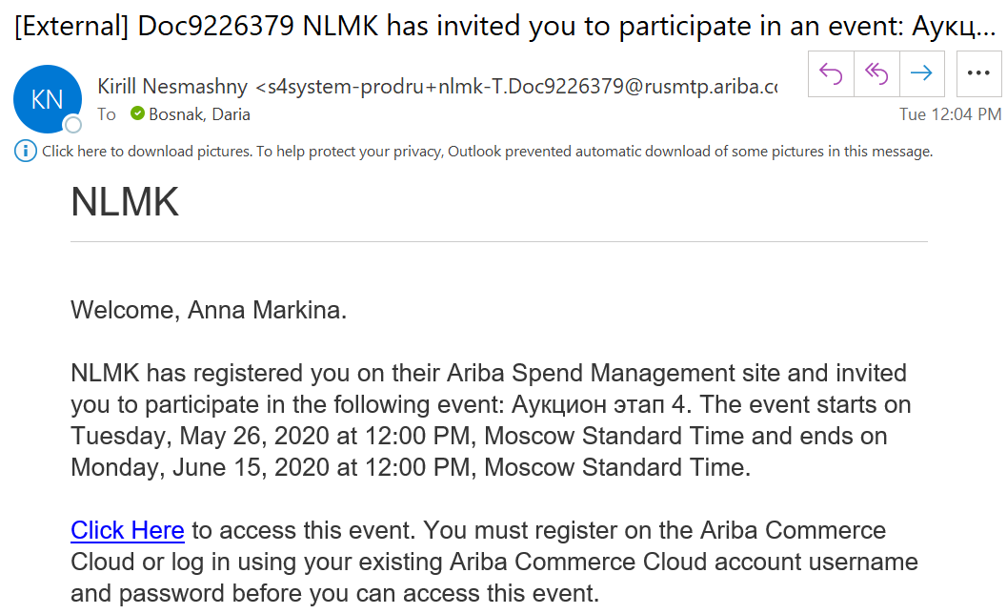
Figure. Sample e-mail notification
After authorization you will see a page of Auction Event. Next, you need to study the terms of participation. For this purpose, you need to click “Review Prerequisites”. (You need to accept the terms of participation before you can view the event content or take part in it).
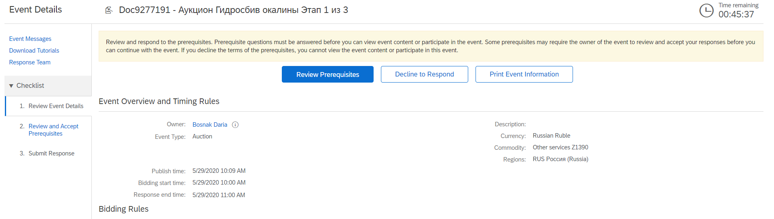
Figure. Event page
Note. In the top right corner you can see the time of the Event (how much time is left before the end of the Event) or in what time the Event will start (if the Event hasn’t started yet).
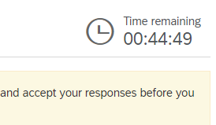
Figure. Time of the Event
Study the terms of participation in an Auction and mark a suitable option with a dot (whether you agree with the terms or not). Mark the following option with a tick: “The buyer has configured this event to allow rejected envelopes to be retrieved and opened while the event remains in Pending Selection status. I accept the terms of this agreement.” Then click “Ok”.
Note. If you reject the terms, you will not be able to view the event content or take part in this event.
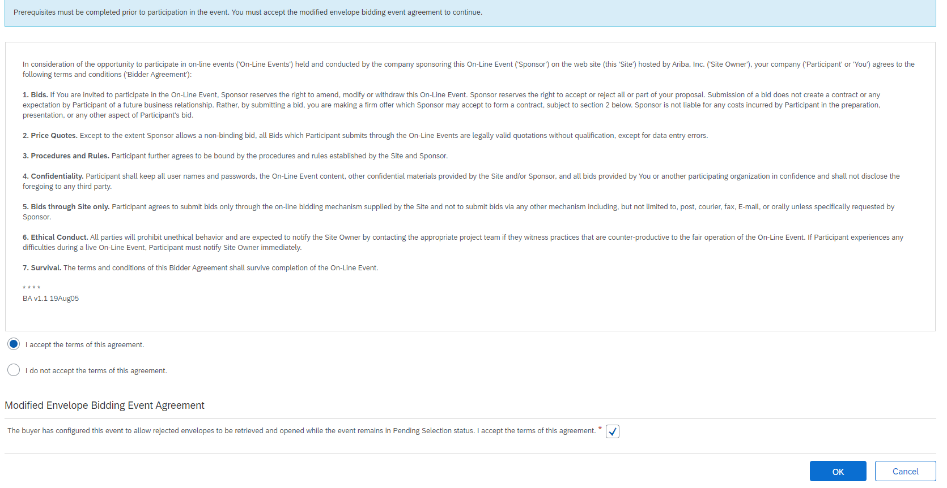
Figure. Studying the terms of participation
In the popup window click “OK” to continue.
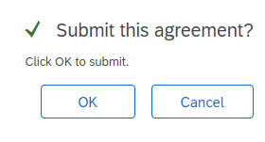
Figure. Response affirmation
Then in “Submit Response” tab you shall study the documents and answer the questions.
If you want, you can download Instructions for Supplier. For this purpose, click on «Instructions for Supplier», select a suitable document in the drop-down list. It will start downloading to your computer where you can study it.
Figure. Instructions for Supplier
Next, study “Main rules of the tender”. It is important information about this Event.
Figure. Main rules of the tender
Next click the name of “Draft Contract for purchasing Main Process Equipment (MPE)” question, and you will see a document with a Draft Contract in Russian and a document with a Draft Contract in English in the drop-down list. Select a suitable option. It will start downloading to your computer where you can study it.
Figure. “Submit Response” tab
Next, select a bank for issuing bank guarantees in the respective field. You can select a suitable option in the drop-down list.
Figure. “Select a bank for issuing bank guarantees” drop-down list
If there is no suitable option in the list - enter your own one. For this purpose, put a tick next to “Other” and enter the name of the bank in the field next to it.
Figure. Enter the name of a bank for issuing bank guarantees
Next, click the name of the following question: “Consent to the penalties / LDs in the amount established in Appendix B resulting from the breach of environmental and OHS regulations applicable on the Buyer's site caused by the Seller, the Contractor, and/or their employees and representatives”, and you will see a document with Appendix B in Russian and a document with Appendix B in English in the drop-down list. Select a suitable option. It will start downloading to your computer where you can study it.
Figure. “Submit Response” tab
Next, in “Applicable Law” field select an applicable law in the drop-down list.
Figure. “Submit Response” tab
The question “The UN Convention on Contracts for the International Sale of Goods (signed in Vienna on 11.04.1980) shall apply to the Contract in the part governing the Equipment delivery (for non-residents)” informs that this convention will apply to the Contract part governing the equipment delivery.
Figure. “Submit Response” tab
If you need you can add comments in “Additional comments” field.
Figure. “Submit Response” tab
Upon completion, go to the beginning of the list of “All content” section and opposite “Please review all the General provisions attached” question put “Agreed” value in the drop-down list after studying the documents in “General provisions” section.
Figure. “Submit Response” tab
Further on data will be entered in Excel format. In the same “Submit Response” tab at the bottom click “Excel Import”.
Figure. “Submit Response” tab
Next, click “Download Content”, and after that an Excel-document will start downloading to your computer where you will continue to work further on.
Figure. Downloading a document to the computer
Open a file which you have just downloaded. Study the content on “Предложения.Proposals” sheet. Here you will see the main sections: Contract terms, Contract price, Payment terms, Delivery time and the Seller’s responsibility.
Important! The amount of values you are proposing in the Auction must not be more than the amount of values that you proposed earlier in the RFP (must be less than or equal to).
Important! All the questions in “Contract price” section are specified for one set of the equipment.
Figure. Excel
You shall enter data in the cells highlighted in orange in “Значение/Value” column (reference to this you will see in the top right corner of the sheet).
Figure. Legend
The cells highlighted in red shall not be filled in as they are filled in automatically as soon as the requirement specified in the cell is met.
Important! After you fill in all the data correctly, red cells will disappear. Make sure that there none of them left!
Figure. Red cells
In “Комментарии/Comments” column you can see auxiliary comments which can show you the translation of cells in “Значение/Value” column or describe the limitations of the cells.
Figure. “Комментарии/Comments” column
Besides, in this column you will see a currency converter to Russian rubles. It automatically converts the data from the respective cells in “Значение/Value” column.
Figure. Currency converter
After you finish entering all the data in the Excel-document, you shall upload this file to Sap Ariba system. For this purpose, click “Choose File” button in SAP Ariba system and upload a required file.
Figure. Document uploading to the system
After that click “Upload”.
Figure. Document uploading to the system
If you see Error like in screenshot below that means not all values are provided or provided incorrectly in Excel. Please check red cells in Excel.
Otherwise, in the popup window you will see a message saying that the import has been done successfully. Click “OK”.
Figure. Finish the import
Next, click “Submit Entire Response” in order to send your proposal.
Figure. “Submit Response” tab
In the popup window click “OK” to continue.
Figure. Response affirmation
If necessary, you can edit your responses before the end of the Event. For this purpose, click “Revise Response”.
Figure. Response revising
In the popup window click “OK” to continue.
Figure. Response affirmation
After the event is finished, you will get a letter of notification by e-mail.
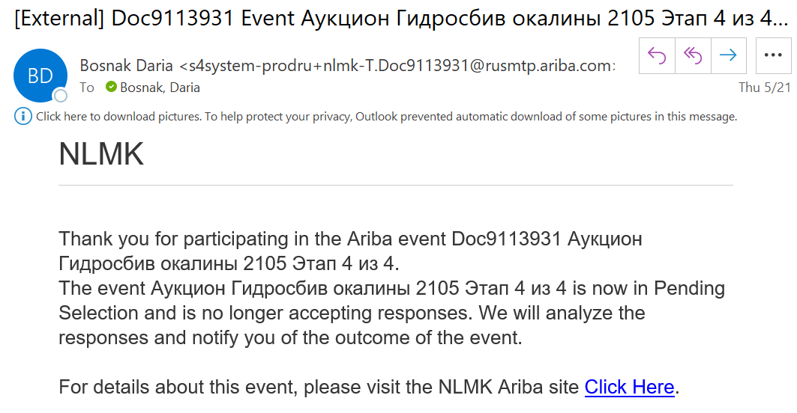
Figure. Sample e-mail notification
Besides, as soon as the stage of an auction is finished, you will receive a letter with information on the stage that has been conducted (the results of this stage) where you will see your Final score following the results of the completed stage and other information.
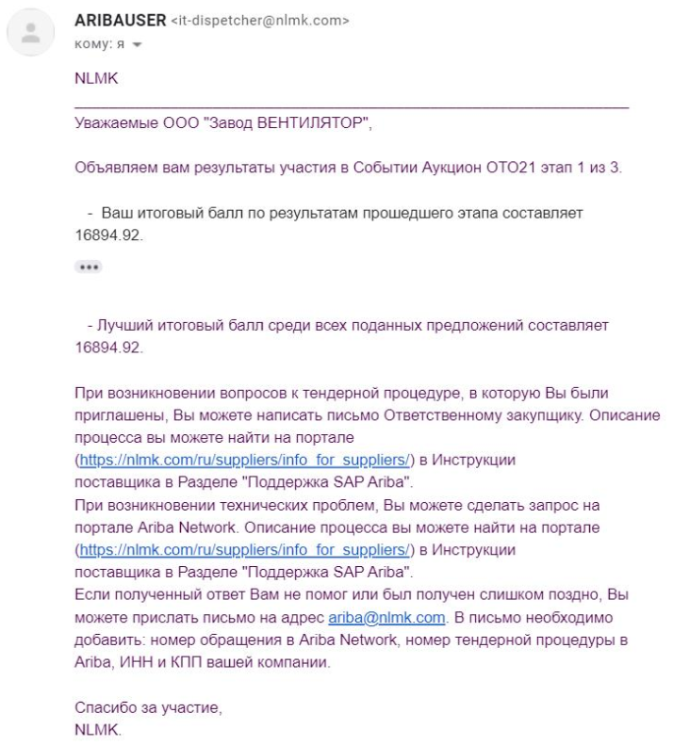
Figure. Sample e-mail notification

Useful links
To receive more detailed information on work in SAP Ariba, you are recommended to use the system help centre. The link to the help centre is placed in the top right corner of the screen - click “Help” icon.
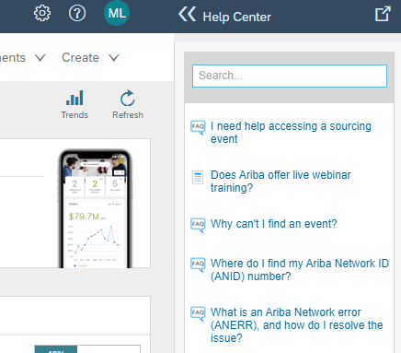
Figure. SAP Ariba Network window
In the Help Center you can search for a question that you are interested in. Besides, you can use the link to SAP Ariba Network system documentation by clicking it.
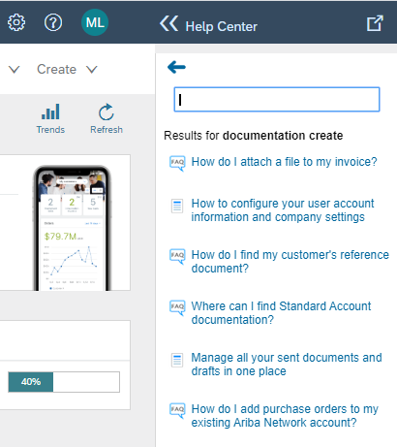
Figure. Help center
After clicking the link, you will see recommendations on how to solve your problem:
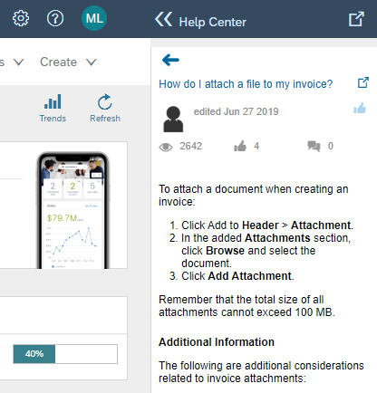
Figure. Help center

SAP Ariba Network support

Technical problem
If you face a technical problem, you can use SAP Ariba technical support or find a solution to the problem on the forum.

Forums
Click “Help” icon in the top right corner. Thus, a window with a search will appear on the right. Click “Support” at the bottom of the window.
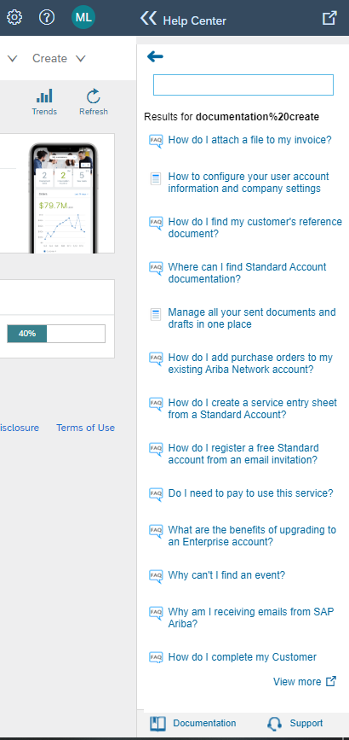
Figure. Help center
You will see a new window “Support Center”.
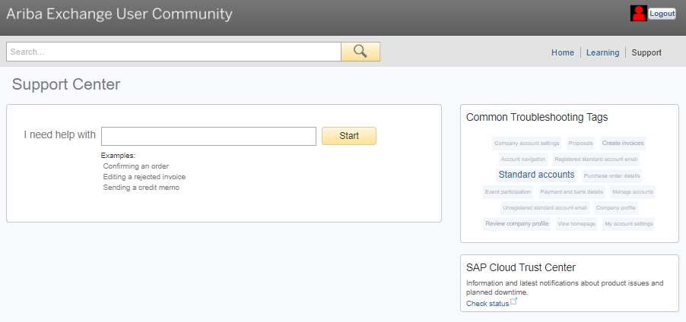
Figure. Support center
In the search field specify what difficulties you faced, for example, problem with registration (see the figure). Thus, you can view typical problems for your request and ways of solving them - click the name of the question.
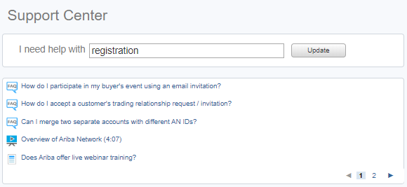
Рисунок. Support Center
Besides, the system can ask you additional suggestive questions in order to help you find the solution to the problem. You shall select suitable options:
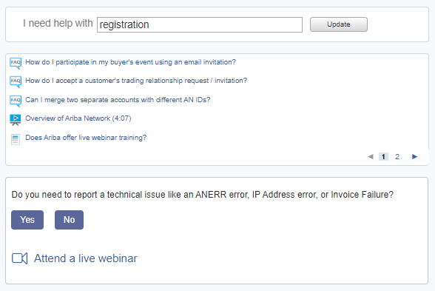
Figure. Additional questions from the system
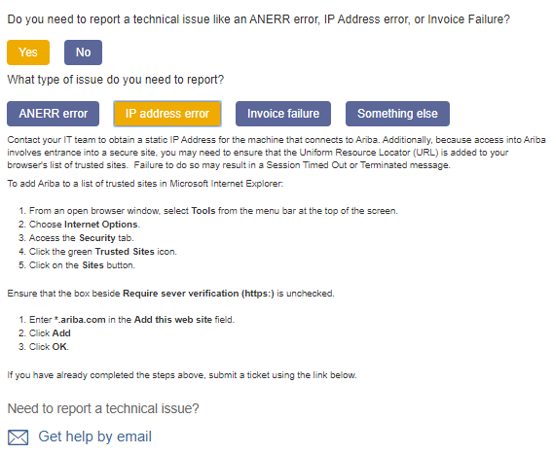
Figure. Additional questions from the system

Request to SAP Ariba technical support centre
If you haven’t found information on the forums or the found solution hasn’t helped you - inform SAP Ariba technical support centre of your problem. For this purpose, click “Get help by e-mail”.
Note. To speed up the process of getting answers on your problem you are recommended to write requests in English and speak to a technical support representative in English.
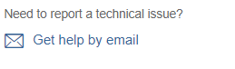
Figure. Get support by e-mail
In the popup window you shall describe your problem in “Problem description” section and enter your data in “Contact information” section.
- “Problem description” section You can see the description of the fields in this section in the table below:
Table 5. Description of fields
Field | Description
Short Description | Enter the brief description of your problem to reflect its essence.
Problem Type | Select the type of the problem you have faced or most suitable one in the drop-down list.
Details | Describe the essence of the problem you have faced in details in this field. You are recommended to write a request in English in order to get the answer as soon as possible. If it’s impossible - write down before the problem description: “Please, call me in Russian” or “Please, answer me in Russian”.
File Attachment | You can attach additional files which can help you describe the essence of your problem - for example, screen shots with errors.

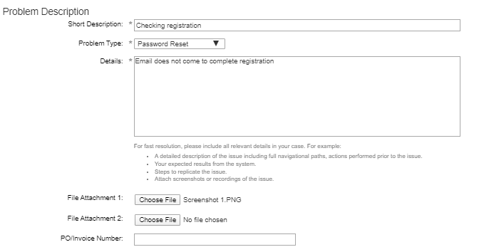
Figure. “Problem description” section
- “Contact information” section You can see the description of the fields in this section in the table below:
Table 6. Description of fields
Field | Description
First Name | Enter the name of a contact person.
Last Name | Enter the surname of the contact person.
Username | Enter the user name of the contact person.
Company | Enter the name of the contact person’s company.
E-mail | Enter the e-mail address of the contact person.
Phone | Specify the phone number of the contact person.
Ariba Network ID | Enter Ariba Network ID number. This field is filled in automatically. If it is not filled in - enter the ID number on your own. You can find this number in the welcome letter from SAP Ariba that you got after registration.

Note. Some of the fields can be prefilled, if the user is authorised in the system.
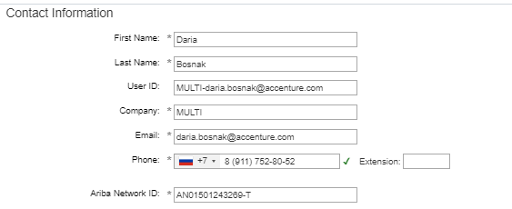
Figure. “Contact information” section
Upon the completion of entering all the required data, don’t forget to put a tick that shows that you agree to communicate the data to Ariba, and send a request by clicking “Submit”.
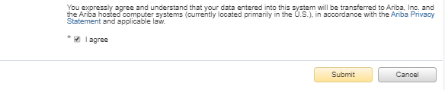
Figure. Send a request to the technical support centre
After that you will see a window with information saying that your request has been sent.
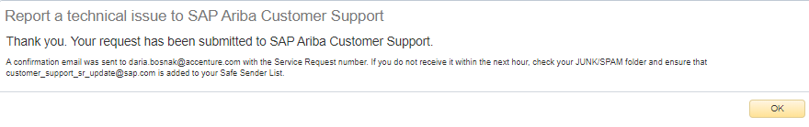
Figure. Request has been sent
You will receive a letter saying that your request has been accepted for processing. Don’t delete this letter.
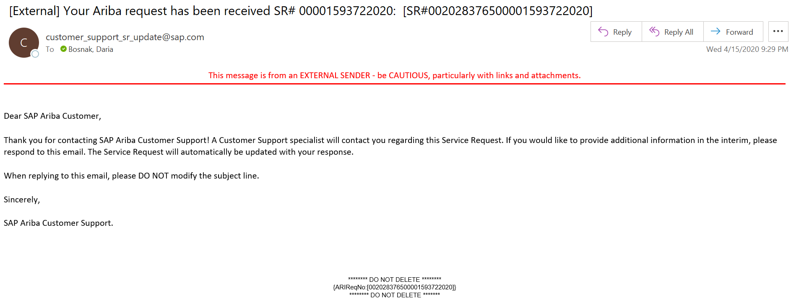
Figure. Sample e-mail notification

Request to NLMK technical support centre
In case the above mentioned ways didn’t help you - contact NLMK technical support centre. E-mail address of the technical support centre - ariba@nlmk.com.
Important! Don’t forget to specify the number of your request sent to SAP Ariba from the previous item. This number is specified in the letter that you got by e-mail after sending the request. The number of the request is stated in the name of the letter, as well as at the bottom of the letter after the main information.
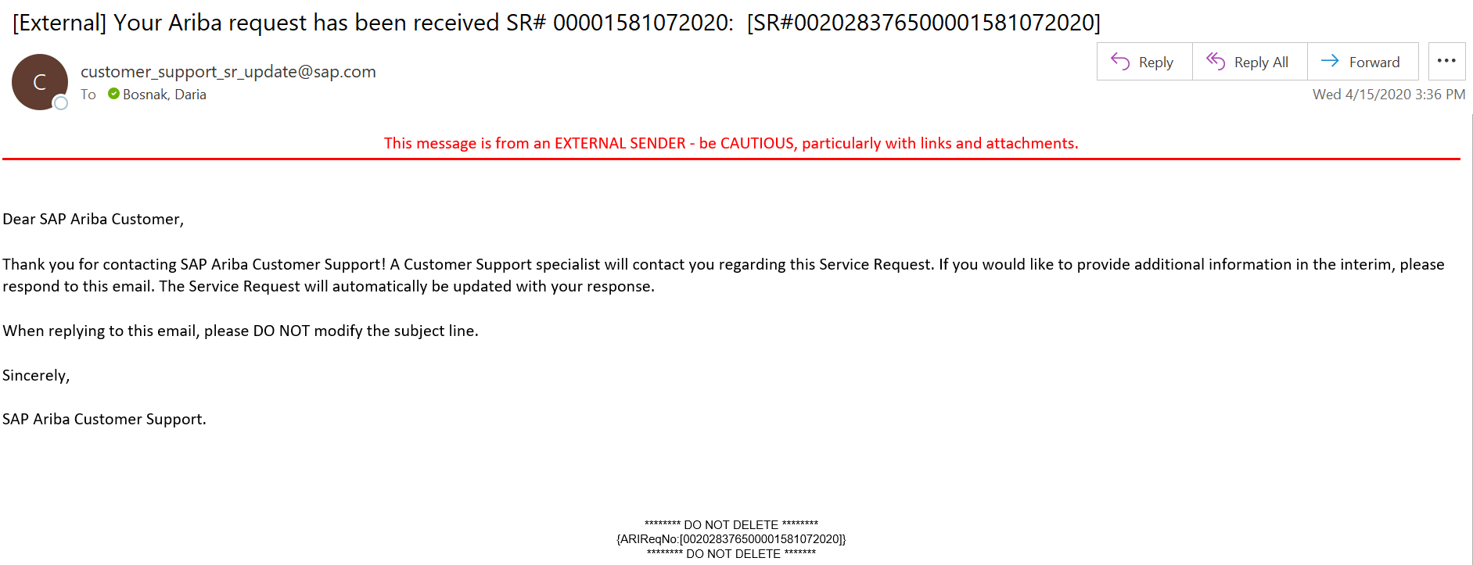
Figure. Sample e-mail notification

Question concerning business process
If you have a question concerning business process, you can send a letter to a person in charge from NLMK’s side.
For this purpose, go to the page of the Event regarding which you have a question, and click “Compose message”.
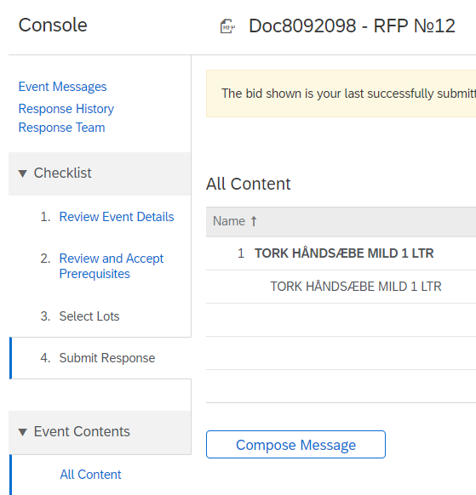
Figure. Event window
In the next popup window in the respective field enter your question and click ‘Send”.
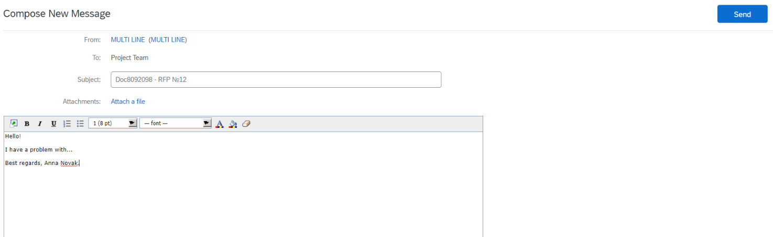

Figure. Create a message
After the person in charge from the company send you a reply, you will get a letter of notification by-email. Follow the link given in the letter.
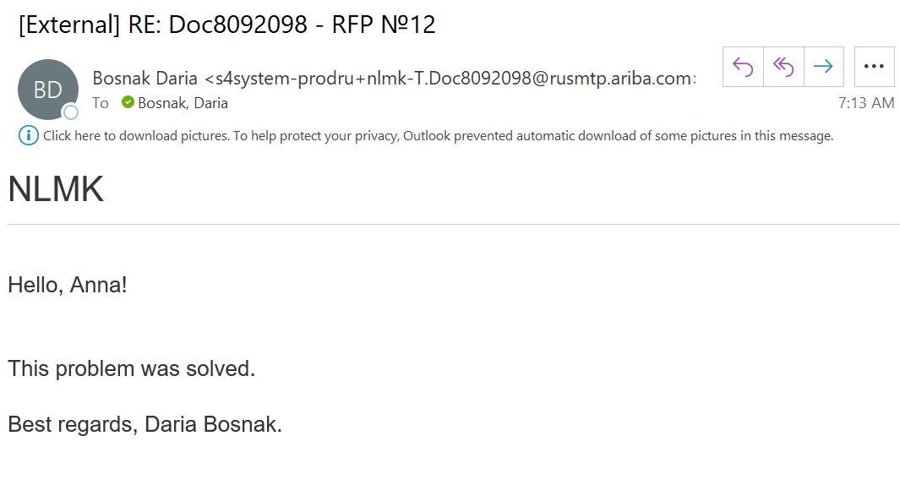
Figure. Sample e-mail notification
Read the letter that you got in SAP Ariba Network system, and answer it by clicking “Reply”, if necessary.

Figure. Message from the person in charge

